Single Jet Dry Type Vane Wheel Water Meter (LXSC-13D7~20D7)
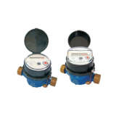
Single Jet Dry Type Vane Wheel Water Meter (LXSC-13D7~20D7)
Share
Packing: | Export Carton
Model NO.: | LXSC-13D7~20D7
Productivity: | 20, 000 PCS/Month
Unit Price: | Negotiable
Shipment Terms: | FOB
Payment Terms: | L/C,T/T,Western Union
Minimum Order: | 500 Pieces
Price Valid Time: | From Sep 22,2011 To Sep 22,2012
HS Code: | 9028201000
Trademark: | Jocund
Origin: | Cixi, Ningbo
Export Markets: | North America, South America, Eastern Europe, Southeast Asia, Africa, Mid East, Eastern Asia, Western Europe

